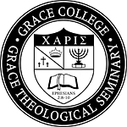

How would you like to win FREE BOOKS by the faculty of Grace Theological Seminary?

Please stop by the Grace College & Seminary table and enter to win books by Tiberius Rata and Matthew Harmon.

